Opening the Terminal & starting the ssh server & Starting all the daemons:

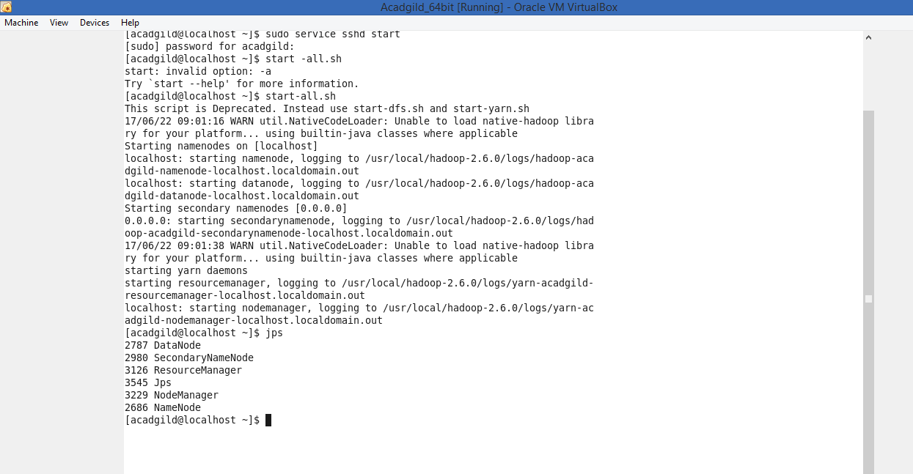

Starting the History server:

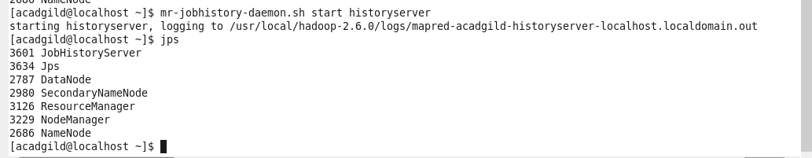

Starting Pig in HDFS mode:

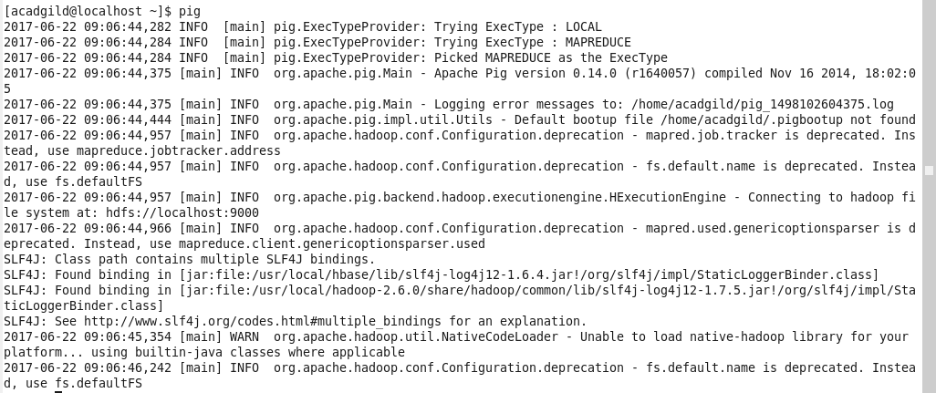

Starting mysql service to start hive:



Starting Hive in HDFS:

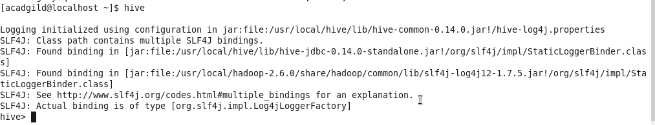

Starting HBASE in HDFS:

